**Guided Solution for Tutorial 2**

Question 3

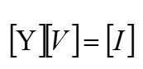1. Apply the formula

2. There are 3 nodes taking one as the reference node results in 2 unknown node voltages so the above will be a 2 X 2 matrix.

3. The mutual admittance will always be negative

4. To solve for the unknown node voltages use Cramer’s rule or find using the determinant method

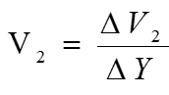 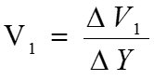

 V1  and  V2  can be found by replacing the first and second column in matrix  by the [I] column matrix respectively.

